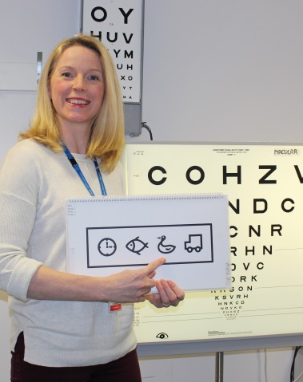
Vision Screening in Lancashire Schools
What is vision screening?
Vision screening is undertaken by a specially trained person who looks at your child’s vision to assess whether they can see without any problems. It takes place at reception class age because visual acuity, eye alignment and binocular vision continually develops from birth up to the age of 7. Early detection and treatment of any defects found can often prevent some of these developing into visual impairment. Young children rarely complain about having reduced vision. If only one eye is affected it is even less likely to be noticed by the child, parents or teachers. The test aims to detect reduced vision early, before it becomes a problem.

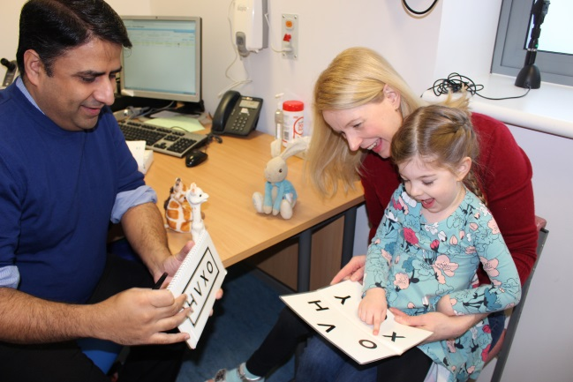
What is involved with vision screening?
We will assess your child’s vision using a letter matching test. The test is fun and your child does not need to know their letters to complete it. During the test an eye patch will be placed over one eye, or a pair of glasses with one eye blanked out will be used. The test is entirely safe and children enjoy playing the letter matching game. It takes approximately five minutes and the screener is trained to make this fun for the child.

Who does the screening?
East Lancashire Hospitals NHS Trust provide the vision screening service for Lancashire. Specially trained screeners go to every school in Lancashire and see children in the reception class. As NHS staff they are all DBS checked, (Disclosure and Barring Service. This check was previously known as CRB, Criminal Records Bureau). The vision screener will see the children in small groups or two at a time and this only takes a few minutes.

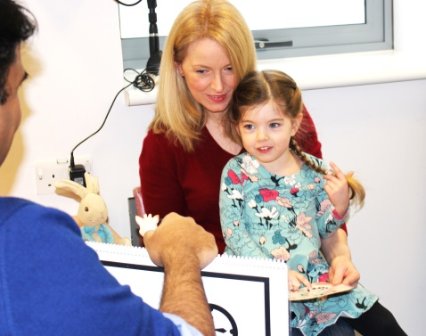
Does my child have to be screened?
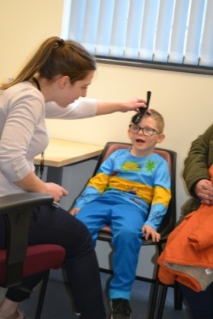
No. A letter will be sent home with your child informing you about the screening and the date it will take place. This is an Opt-out letter and only needs to be returned if you do not wish your child to be tested. If you do not receive a letter please ring the school for a copy.

What happens if my child is absent on the day of screening?
If a child is absent on the day of screening or unable to perform the screening test, you will be sent a letter inviting your child to attend an appointment at a health centre near to you. The appointments take approximately 15 minutes.
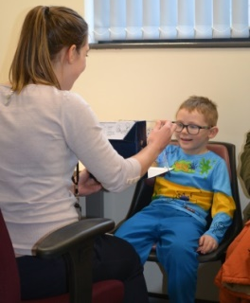

What will happen during the visual screening assessment?
During the school lesson, a couple of children will go to the room where the vision screening is being held. One eye will be covered and the child will be asked to identify shapes or letters held by the screener. This will then be repeated with the other eye. The screeners are trained to make this fun for the child. The screening only takes approximately 5 minutes then the children return to their lesson and the next couple of children go to be screened until everyone in the class has been seen.
What happens if my child passes?
We will send you a letter to inform you that your child has passed the vision screening. The results are recorded in a secure electronic system and this information is then sent to your child’s GP and school nurses so they know your child has been screened and no issues found. No one else can access this information.
What if a child does not pass the assessment?
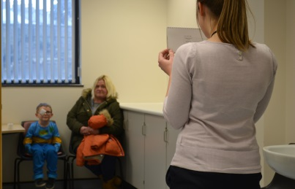
Sometimes a child does not pass the screening. This may be because they are tired or not able to concentrate on the day of screening. If the screener is unsure if there is an issue with your child’s sight, they will send you a letter to ask you to attend another appointment at a health centre nearby to double check and be sure.
If your child does not pass due to sight problems, they will be referred for further tests. These could be carried out by an Orthoptist, who treats issues with the muscles of the eye, an Optometrist who prescribes glasses, or a hospital eye Doctor, depending on the results of the screening. You will be sent a letter informing you of the screening results and a further appointment will be arranged.

Contact details
If you live in the Blackburn, Burnley, Pendle, Rossendale, Ribble Valley, West Lancashire, Chorley and South Ribble areas please contact:

Lancashire Vision Screening Lead: Stephanie Smith.
The Orthoptic Department
Burnley General Teaching Hospital
Casterton Avenue
BB10 2PQ
Tel: 01282 805568
Email address: lancashirescreening.elht@nhs.net

If you live in the Blackpool, Preston, Lancaster, Morecambe, Wyre and Fylde areas please contact:

Blackpool Orthoptist: Rebecca Smart
Blackpool Victoria Hospital
Whinney Heys Road,
FY3 8NR
Tel: 01253 953457
Email address: Rebecca.Smart@bfwhospitals.nhs.uk

