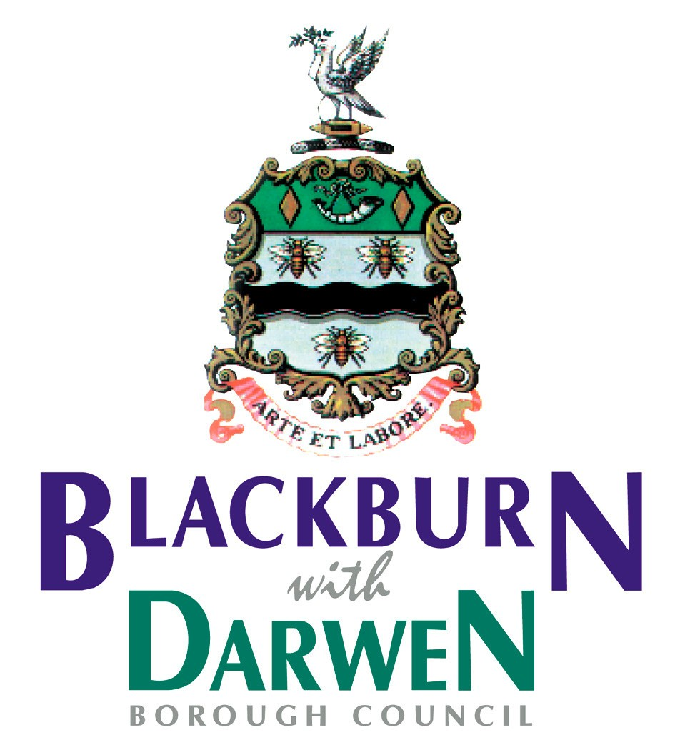

Dear Parent/Carer

You will have read and heard about the rise of cases of Covid 19 in Blackburn and Darwen, and across the North West and that these have been linked, in part to a new variant of the disease first identified in India. Whilst there is currently no evidence that this causes more severe illness, there is evidence that it is more infectious and has been classified as a ‘Variant of Concern. Public Health England is currently working hard to understand this variant better.

Testing:
Following the identification of cases of this Variant of Concern, Blackburn with Darwen Council has been working closely with Public Health England and NHS Test and Trace to develop a programme to increase access to PCR test kits called surge testing and enhanced contact tracing for across the borough.
Anyone living, working or going to school in Blackburn with Darwen is strongly encouraged to take a PCR test.
We are requesting your supporting and asking:
- For your child to undertake a PCR test within the Surge Testing
- PCR tests will be given out by school and should be registered and carried out at home
- Completed tests should be delivered back to school the following day. These will then be taken to a collection point, to enable the laboratory analysis and genomic sequencing. Please do not put completed tests in the post.

School will be able to provide PCR test kits to their school community. However, if you would prefer, you can also access PCR testing via a number of other routes:
- Mobile Testing Units (MTU’s)
    - Darwen, Market Square
    - Pleasington Playing Fields
    - Ewood Park, Darwen End
    - Corporation Park, Main Entrance
    - Bangor Street Community Centre (until 13th June)

- Community Hubs where you can collect PCR test kits will be open Monday to Friday 8am-6.30pm, and 10am-4pm on weekends:
- Revidge Fold United Reform Church, Shear Brow, BB1 8DS
- Corporation Park, Main Entrance, BB2 6AH
- The Works Over Darwen, Darwen, BB3 2RG
- West Park Lodge, Corporation Park Road, BB2 6DE
- Witton Park Arena, BB2 2TP
- Shadsworth Children’s Centre, BB1 2JN

In addition, from these locations people can also collect PCR tests for themselves and their household/neighbours, take them home, carry out the tests and then return them to the same place they collected them, for sending to the lab for testing.
People will only need to take one test each, and we urge those who test positive to self-isolate with everyone in their home to stop the spread of the virus.
Anyone who has symptoms of Coronavirus should stay at home and book a free test online or by phone, so they can be tested at a testing site or have a testing kit sent to their home.Tests can be booked on this link: www.gov.uk/get-coronavirus-test or by calling 119.
We want to remind you that as well as getting tested if you have symptoms, it is vital everyone in the borough continues to follow the guidelines and the ‘Hands, Face, Space, Fresh Air’ rules – as this is the most effective way to control the spread of all variants of coronavirus. Please also continue with the weekly lateral flow testing. In addition, we are reminding all eligible adults to come forward to be vaccinated.

Vaccinations:

Vaccinations are now open to anyone eligible aged 18 and over. If you are unsure if you are eligible, please turn up at a vaccination centre and speak to the team. More people are eligible than you would think, please don’t assume you are not eligible.

The new walk-up vaccination sites have been arranged for the convenience of local residents - please see the NHS BwD CCG Website for up to date information. Anyone who is eligible can also book into the appointments for their first dose.

Walk-in sites include:
- Everest Pharmacy, 21 Cemetery Road, Darwen BB3 2LZ (Available now)
- Burnley General Teaching Hospital, Casterton Ave, Burnley BB10 2PQ
- Acorn Medical Centre, Blackburn Road, Accrington, BB5 1RT

School Processes:
Just as a further reminder we would like to set out how you and your family can help to prevent passing the virus on. These are the steps that you must take:

Child with COVID-19 Symptoms
If your child develops symptoms of COVID-19 please do not send them to school and ensure a test is taken.

Child asked to self-isolate
If your child has been asked to self-isolate, due to being a confirmed case of COVID-19 or being a school contact of a confirmed case, please take the following action:

- Your child must stay at home
- Your child must not go to school, public areas, shops, clubs or out of school settings and do not use public transport or taxis.
- Your child must not meet friends during a 10 day period
- Any exercise should be taken within your home.

Child develops COVID-19 Symptoms during period of self-isolation
If during the period of isolation your child experiences symptoms of COVID-19, please take the following action:

- Arrange a COVID-19 test for your child as soon as possible
- Once you have the test result you must inform your child’s school or setting along with any clubs or out of school settings your child attends.

It is really important you support your child to follow this guidance in order to keep our community safe and reduce the risk of transmission.

Of course, if at any time your child becomes more unwell or their symptoms worsen, do seek medical advice straightaway.

If you do have any questions, please do check our Council website https://www.blackburn.gov.uk/coronavirus/schools-covid-19-information or contact your child’s school in the first instance.

Best regards
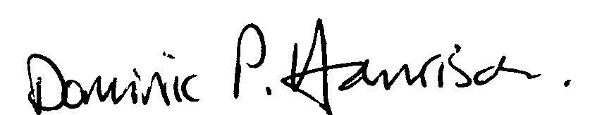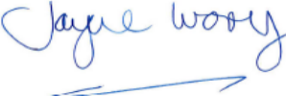

Dominic Harrison  Director Public Health |  |  |  | Jayne Ivory  Director Children’s Services

