Zoom Guide – parents and pupils

Getting Started with Zoom
Zoom is a free video conferencing solution (at least for participants). It allows multiple people to come together online and thus has been popular choice for online classes and lessons.
To make use of Zoom, you would need a computer, iPad or a smart phone like an iPhone or Android phone. The device should have a camera if you intend to do video conferencing. If not, you will be reduced to just audio conferencing.
The free Zoom client / app can be downloaded from the Zoom website (under Resources > Download Client), or from the Apple App Store or Google Play Store.
When you open up the client / app, you will not need to sign up to Zoom, Zoom accounts are not to be used for children under 16 so simply click ‘Join meeting’ instead.
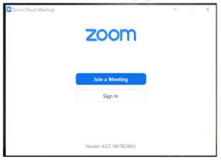
How to Join a Zoom Meeting / Online Class
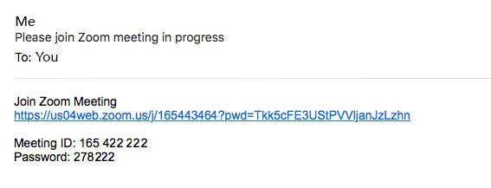
In order to join a meeting, you will receive an invitation. The invitation message should look like this:

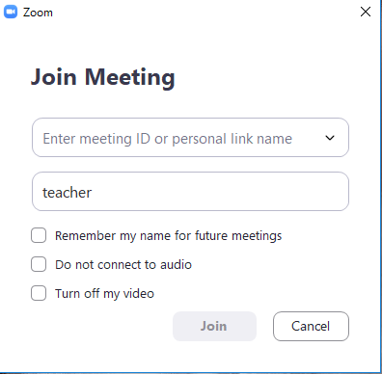
To join the meeting, you can either click on the link, or enter in the Meeting ID and Password on the Zoom app / client.

Leave these blank and unticked so that you join the meeting with video and sound

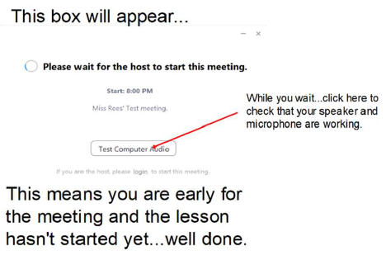

When you enter into the video conference, you have the choice of either having your video on or off. Once inside, you should also be able to see the other meeting participants.
There are different views available – speaker view and gallery view. The button to toggle between the various views is at the top right of the screen on the computer desktop app.

At the bottom of the screen is a black bar. The functions you will need to know are:
Mute: This turns on and off your microphone. As a tip, if there are many people in the meeting, you can set this to mute so that it doesn’t become too noisy.
Stop/Start Video: This turns on and off the video function.
Reactions: This allows you to give a “thumbs up” or “clap”.
End Meeting: Use this to leave the Zoom session.

