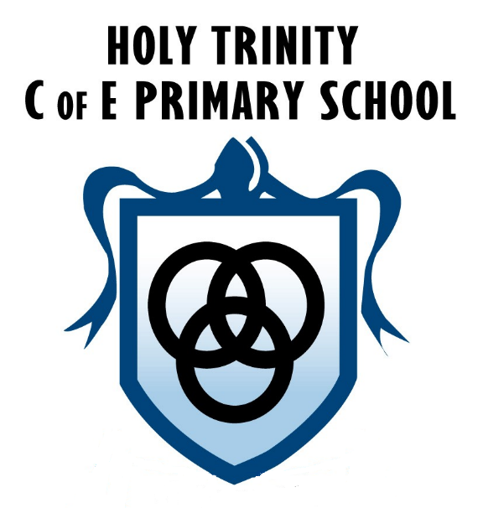
HOLY TRINITY CE PRIMARY
PSHE POLICY

Member of staff responsible: L Sumner
Date policy written: September 2020
Date approved by governing body: ___________
Date to be reviewed: September 2021

Our Vision
‘Learn together, shine together’

Mission Statement

At Holy Trinity our mission is to ensure that each person in our school community can flourish and live life in all its fullness as they know they are cherished and loved by God and are provided with the best possible opportunities to learn together, work hard together and shine together. We support each other as we learn to live out Christian values, making our school a happy, friendly, safe place to be.

Personal, Social and Health Education (PSHE) and Citizenship Policy (PSHCE)
Intent
PSHCE provision at Holy Trinity Primary School enables pupils to develop the knowledge, skills and understanding they need to lead confident, healthy and independent lives and to become informed, active and responsible citizens. These skills and attributes help pupils to stay healthy, safe and prepare them for life and work in modern Britain. Provision is tailored to meet the needs of our pupils and address local, national and global priorities. PSHCE is key to the promotion of the spiritual, moral, social, cultural (SMSC) as well as the mental and physical development of pupils at the school.
At Holy Trinity we will:
- provide a curriculum that is broadly based and balanced and which meets the needs of all pupils
- make good provision for personal, social, health and economic education (PSHE) for our children, drawing on good practice.
- promote the spiritual, moral, social, cultural, mental and physical development of pupils at the school and society, and prepare pupils at the school for the opportunities, responsibilities and experiences of later life
Implementation
Our PSHE education provides learning opportunities and experiences that deal with the real life issues children and young people face as they grow up.
Our annual Life Education Bus covers the following topics:
My body, feelings, meet the brain, it’s great to be me, decision making and friendships
Our PSHE framework ‘SCARF’ ensures our teaching is coherent and cohesive throughout school from EYFS to Year 6.
Our class PSHE sketchbooks ensure that PSHE learning is not based upon a child’s ability to write answers to questions but includes getting our children involved in decision making, discussions, debates, practical/hands on activities, handling resources and welcoming and communicating with visitors who are invited into school.
We have termly themes throughout school they are;
S-safety
C-caring
A-achievement
R-resilience
F-friendship
PSHCE provision will be delivered across four strands:
Discrete PSHE provision
• Regular planned opportunities with clear learning objectives taken from the scheme of work, supplemented by other relevant materials where appropriate. The scheme of work for PSHCE is available on the school server.

Contribution of other subjects
• Cross-curricular lessons with clear links to PSHCE i.e. Science, R.E, P.E, Drama and Literacy
• Teachers seek to make links with other subjects across the curriculum wherever appropriate
• General teaching: the teacher and other adults as role models and a classroom climate that creates expectations of appropriate social behaviour and interaction

Additional curriculum experiences
• Assemblies (whole school, key stage, class assemblies)
• Use of visitors and visits
• Sporting and team activities
• Community projects
• School Council activities
• Concerts and events
• Charity support and fundraising
• Anti-bullying week
• SEND support
• After school and lunchtime clubs
• Parental involvement
• Target setting (setting and achieving goals)

Behaviour around school
Management of behaviour is dealt with in the behaviour policy, in conjunction with which this policy should be considered. We aim to be positive in our management of behaviour, actively seeking out opportunities to reward children for socially appropriate behaviour throughout the school day. This includes during lessons, playtimes, lunchtimes and when moving around the school building.
Through PSHCE lessons and discussion with groups or individuals, we aim to improve pupils’ ability to manage their own behaviour effectively.

Expectations are made explicit through the use of:
• School Rules
• Class Recognition Boards
• Individual pupil targets
• Role modelling E.g. Fantastic walking.
• House points and other reward systems
We have a successful School Council that provides our young people with a forum to discuss their opinions and thoughts. It allows students to have a voice that is proactive in promoting positive change within the school. Students that join the school council enjoy being part of the decision making process. It gives them a sense of responsibility and pride in their school.

Equality and Diversity
We promote the needs are interests of all pupils, irrespective or gender, culture, ability or aptitude by careful consideration of our pupils’ knowledge and needs and through differentiation and support in all PSHE lessons. Teaching will take into account the ability, age, readiness and cultural backgrounds of our young people, and those with English as a second language to ensure that all can access PSHE education provision. We promote social learning and expect our pupils to show a high regard for the needs of others by leading by example and using the ‘ground rules’ for each PSHE lesson effectively. We will use a wide variety of teaching and learning styles, ensuring that teaching reflects and meets the personal development needs of the children. We will use PSHE education as a vehicle to address diversity issues and to ensure quality for all through effective teaching of the PSHE curriculum.

Impact
At Holy Trinity children will achieve their academic potential, and leave school equipped with skills
they will need throughout later life;
-Children will grow in their self-knowledge, self-esteem and self-confidence
-Our children will to distinguish right from wrong and to respect the civil and criminal law of England.
-Children will take responsibility for their behaviour, show initiative, and to understand how they can contribute positively to the lives of those living and working in the locality of the school and to society more widely.
Assessment
There is no statutory requirement for end of key stage assessment. Some aspects of SRE and health education, which are statutory elements of the Science National Curriculum, need to be assessed according to science targets. Assessment of PSHCE takes place in accordance with the school assessment procedures for foundation subjects. Continuity and progression in PSHCE is ensured through the use of appropriate learning objectives taken from the Coram SCARF scheme of work.

