Oxford Owl guide for parents and pupils
Visit www.oxfordowl.co.uk/welcome and click on enter site for Oxford Owl for Home.

For eBooks: Click on Browse eBooks on the page and then scroll to the bottom of the page where you can browse books by book band colour eg. Red, Orange, Yellow etc. Choose the book band colour your child is currently on. On the page it then takes you to, you will see a number of books shown on the shelves. Here you can select a book, where the option will come up to log in.
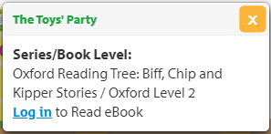

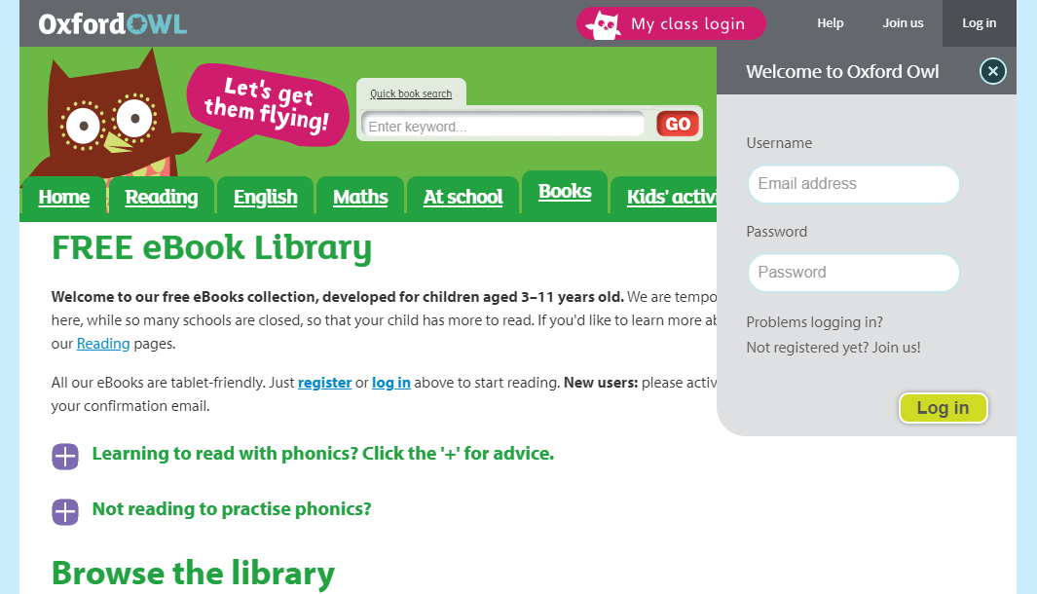
Click ‘log in’, and on the next page, click My class login where you can enter the details given to you by your child’s class teacher.

For Read Write Inc. support: Visit https://home.oxfordowl.co.uk/reading/ and select the Read Write Inc. support box.
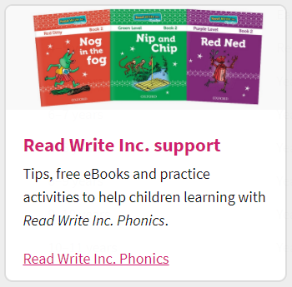
On this page you will see guidance for practising sounds with your child,
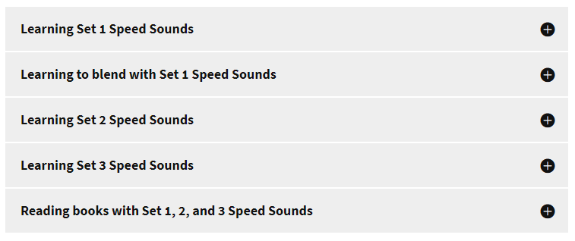

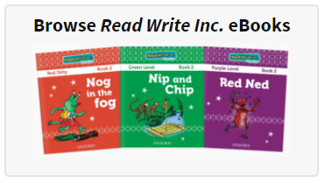
Read Write Inc. books to support your child,

and parent tutorial videos to watch for guidance.
